**Before devops**

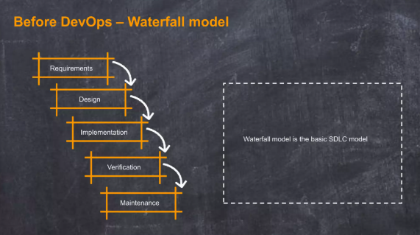

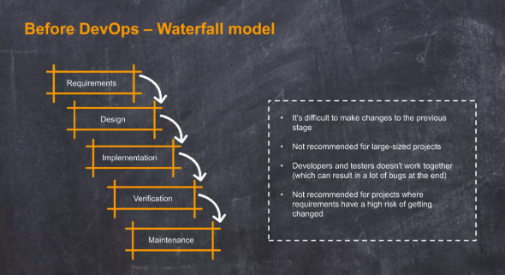

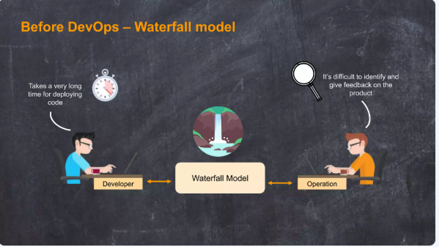

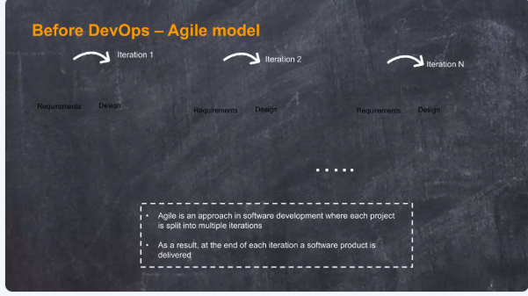

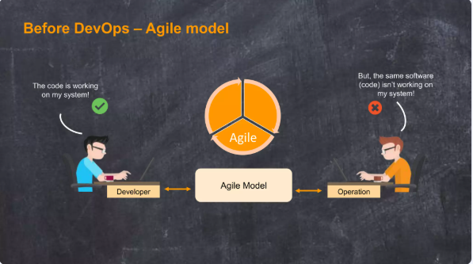

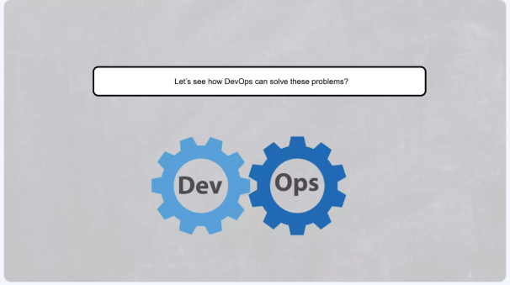

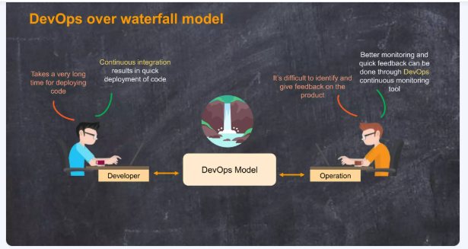

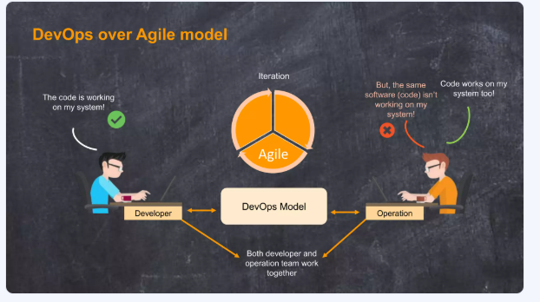

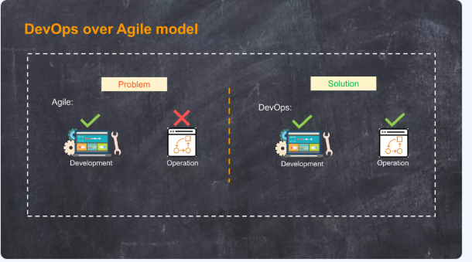

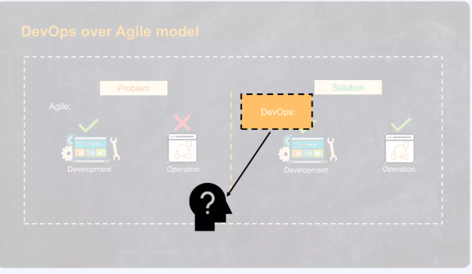

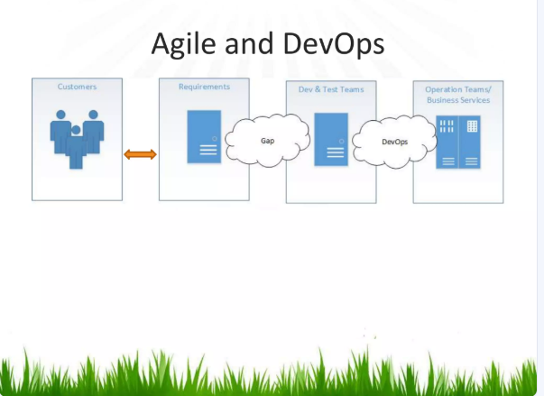

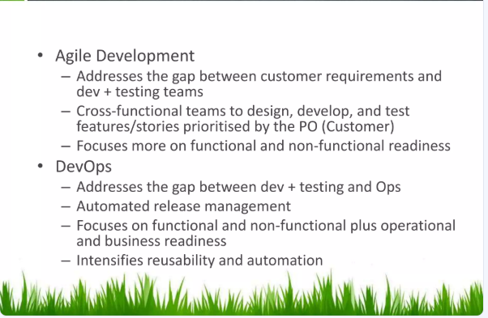

**DEVOPS**

What is DevOps?

The DevOps is a combination of two words, one is software Development, and second is Operations. This allows a single team to handle the entire application lifecycle, from development to **testing, deployment**, and **operations**. DevOps helps you to reduce the disconnection between software developers, quality assurance (QA) engineers, and system administrators.

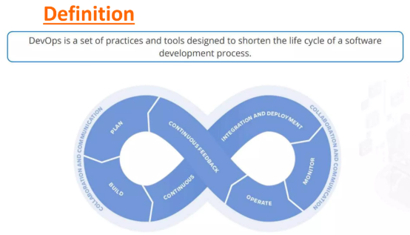

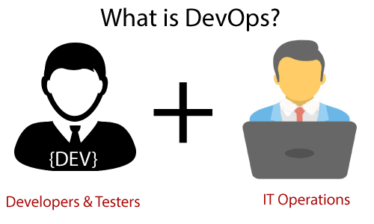

## DevOps History

* In 2009, the first conference named **DevOpsdays** was held in Ghent Belgium. Belgian consultant and Patrick Debois founded the conference.
* In 2012, the state of DevOps report was launched and conceived by Alanna Brown at Puppet.
* In 2014, the annual State of DevOps report was published by Nicole Forsgren, Jez Humble, Gene Kim, and others. They found DevOps adoption was accelerating in 2014 also.
* In 2015, Nicole Forsgren, Gene Kim, and Jez Humble founded DORA (DevOps Research and Assignment).
* In 2017, Nicole Forsgren, Gene Kim, and Jez Humble published "Accelerate: Building and Scaling High Performing Technology Organizations".

## DevOps Architecture Features

Here are some key features of DevOps architecture, such as:

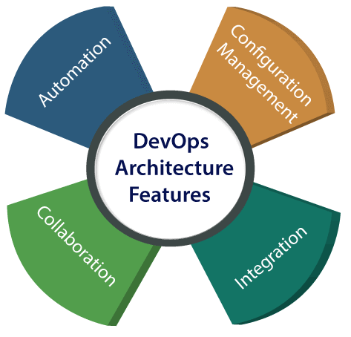

# DevOps Architecture

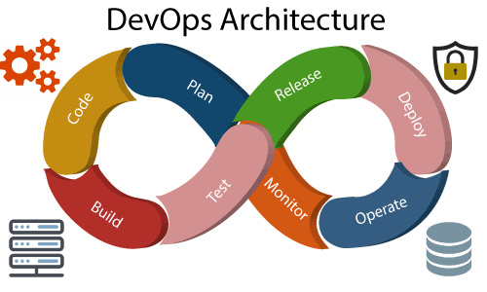

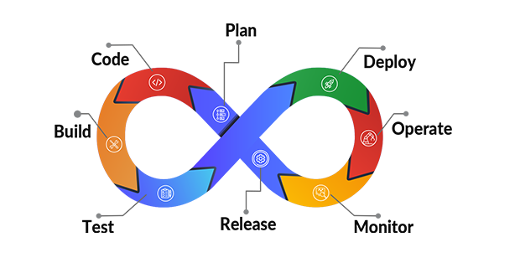

Development and operations both play essential roles in order to deliver applications. The deployment comprises analyzing the **requirements, designing, developing**, and **testing** of the software components or frameworks.

Below are the various components that are used in the DevOps architecture:

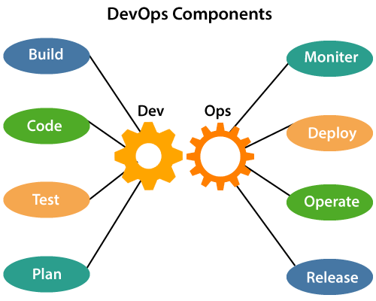

# DevOps Lifecycle

DevOps defines an agile relationship between operations and Development. It is a process that is practiced by the development team and operational engineers together from beginning to the final stage of the product.

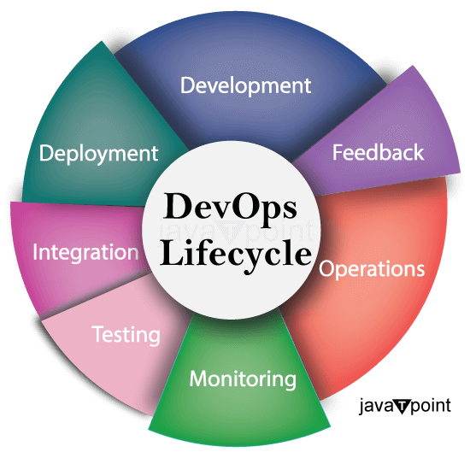

DEV OPS

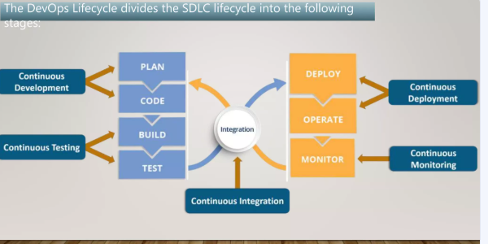

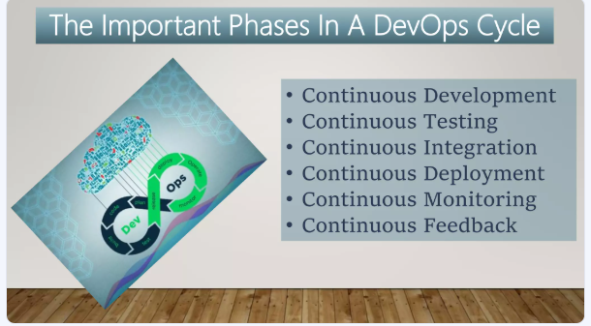

### Continuous Integration

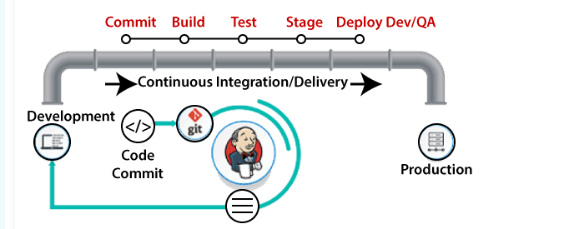

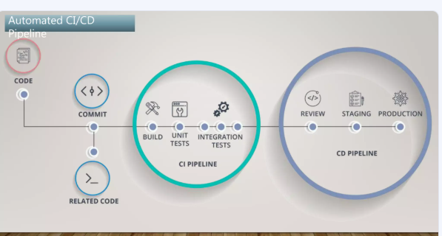

### Continuous Testing

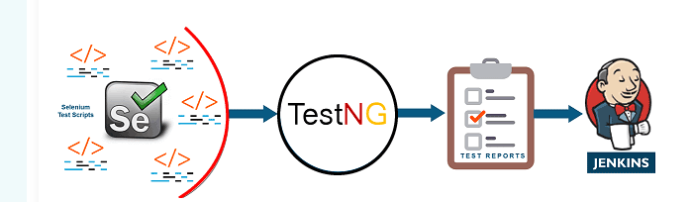

### Continuous Monitoring

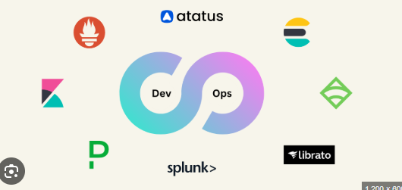

### Continuous Deployment

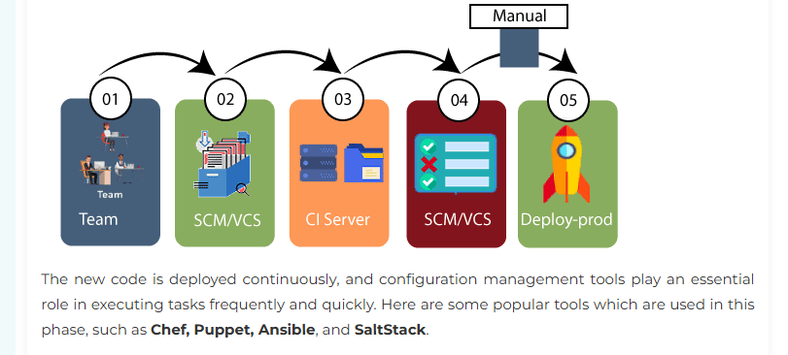

**Tools Details**

* version control system (VCS) : GIT
* Build and Package : Maven, Docker
* Functional Testing Environmental : Terraform, Ansible
* CI/CD Engine : Jenkins
* Monitoring : Nagios,Grafana,Cloud watch

# DevOps Engineers

DevOps Engineer is an IT professional who works with system operators, software developers, and other production IT staff to administer code releases.

DevOps engineer understands the software development lifecycle and various automation tools for developing digital pipelines.

DevOps have hard as well as soft skills to communicate and collaborate with development, testing, and operations teams.

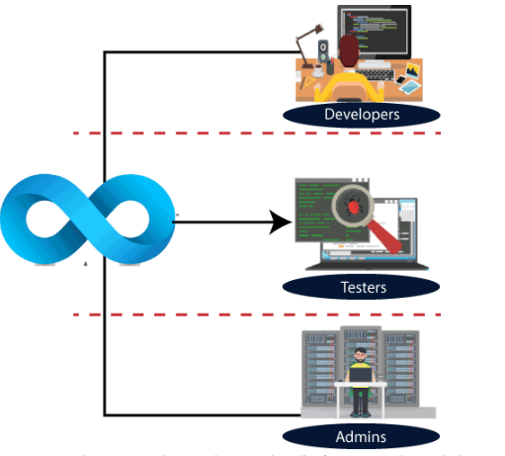

**Operations by DevOps Engineer**

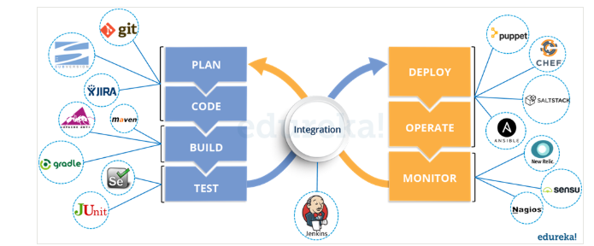

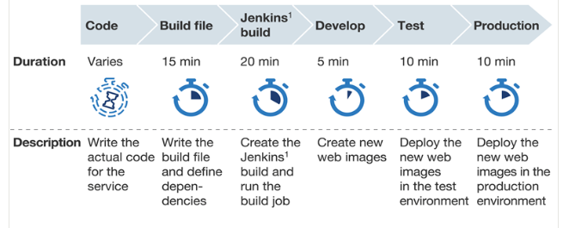

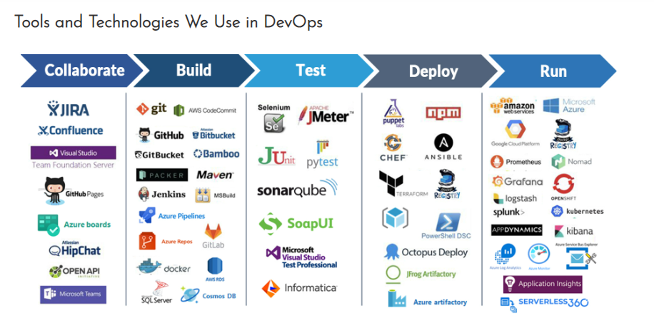

**DevOps Career Opportunities**

Once you got a mastery in DevOps, then there are multiple career open in front of you. Here in this section we have listed best career opportunities.

* [DevOps Engineer](https://www.geeksforgeeks.org/how-to-become-a-devops-engineer/)
* [Site Reliability Engineer](https://www.geeksforgeeks.org/cohesity-site-reliability-engineer-on-campus-interview-experience/)
* Cloud DevOps Engineer
* [Automation Engineer](https://www.geeksforgeeks.org/how-to-become-an-automation-engineer/)
* Security DevOps Engineer
* Release Engineer
* [CI/CD Engineer](https://www.geeksforgeeks.org/what-is-ci-cd/)
* DevOps Consultant
* Tool chain Developer
* Quality Assurance (QA) Engineer with DevOps Skills

### Salary (Based on Company and Experience)

No doubt, you get a very handsome salary but it also depends on company-to-company and also on your experience level. To clear up any confusion, here’s a complete idea of salary based on company and experience.

**Based on Company**

| **Company** | **Salary (on an average)** |
| --- | --- |
| Google | 24.9 LPA |
| Amazon | 11 LPA |
| IBM | 10 LPA |
| Cognizant | 8.5 LPA |
| TCS | 7 LPA |

**Based on Experience**

| **Experience-Level** | **Salary (on an average)** |
| --- | --- |
| Beginner | 5 LPA |
| Intermediate | 6.5 LPA |
| Expert | 11 LPA |

### Skills Required

Indeed, there are numerous skills you should engross yourself with and keep brushing those to be proficient in any specific domain. But, there are certain skills you should focus on to become an expert in DevOps engineering.

**Concepts on which you have to focus on are:**

* Automation with CI/CD (Continuous Integration and Continuous Delivery) tools like TeamCity and Jenkins
* Deployment tools like Ansible and Docker
* Kubernetes and Containerization
* AWS
* Cloud Computing
* Linux fundamentals
* Server configuration management
* Hands-on Cloud Platforms
* DevOps tools and technologies
* Managing databases like Mongo, and MySQL.

## List of Companies Using DevOps

| **Company Name** | **DevOps Implementation** |
| --- | --- |
| **Amazon** | Extensive use of DevOps in AWS, CI/CD pipelines, and automation tools. |
| **Google** | DevOps practices for managing large-scale infrastructure, automation, and microservices. |
| **Netflix** | DevOps for continuous delivery, auto-scaling, and rapid deployment of features. |
| **Facebook (Meta)** | DevOps for managing large-scale data centers, automation, and site reliability. |
| **Microsoft** | DevOps integration in Azure, automated deployments, and CI/CD practices. |
| **Etsy** | Early adopter of DevOps, using it for rapid deployment and continuous integration. |
| **Uber** | Utilizes DevOps for microservices, automation, and scaling infrastructure. |
| **Airbnb** | Implements DevOps for infrastructure as code, automation, and scaling operations. |
| **Spotify** | DevOps for continuous integration, automation, and microservices architecture. |
| **LinkedIn** | Uses DevOps for infrastructure management, automation, and rapid feature releases. |

